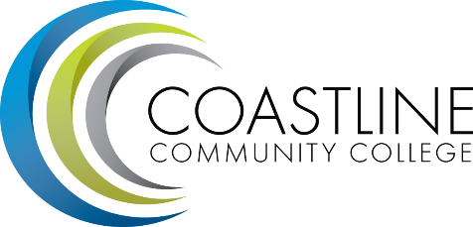

CMT Assessment of Committee Behaviors

Committee Behaviors | Barriers | Solutions
COLLABORATIVE: Sharing, inclusive, open to input, respectful of diverse opinions, characterized by meaningful dialogue
TRANSPARENT: Open, easy to understand, clearly defined, characterized by effective and meaningful communication with the College community | - Decisions are limited by external governance  - Take ownership of the agenda  - Limited questioning and following-up | - Provide more opportunities for smaller workgroup projects  - Support an environment of openness, courage and honesty  - Continue discussions around major topics, follow-up on projects, and hold groups accountable
EVIDENCE-BASED: Reliant upon relevant, accurate, complete, timely qualitative and/or quantitative information, not based solely on assertions, speculations, or anecdotes | - Trying to identify a clear direction as we are perceived in going in different directions  - Too many conflicting priorities | - Create the agenda for the next meeting and the end of the current meeting  - Focus on action  - Requested data with a focus  - CMT can drive common discussions and throughout the college
EFFECTIVE: Working properly and productively towards the committee's intended results | - Duplication of effort  - More reporting and less action  - Limited knowledge of should be presented to the group | - Understanding what is needed to share  - Sharing more information from conferences
EFFICIENT: Performing well with the least waste of time and effort, characterized by serving the committee's specified purposes in the best possible manner | - Limited direction  - Too many sidebar discussions  - Lack of follow-through | - Establish an action-based agenda  - Stay on track with identified deliverables and timelines  - Charge taskforces to complete the work

